**Ambassador**

When we build our application, our application needs to communicate with another application. It acts as a one type of entry point for different application (Kind of proxy services)

* Overview: This pattern is a specialized sidecar responsible for hiding the complexity and providing the unified interface for accessing the services
* To demonstrate this pattern, let’s say we use a cache for application. In the local developer environment, we want to use Memcached and in production we want to use etcd.
* So, we create an Ambassador container which accesses the Memcached and also the ambassador container which uses local Memcached
* Depending on the environment we can use the Ambassador container. 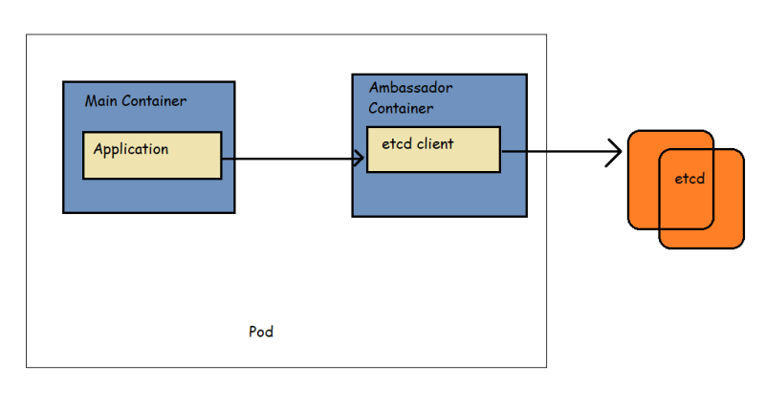

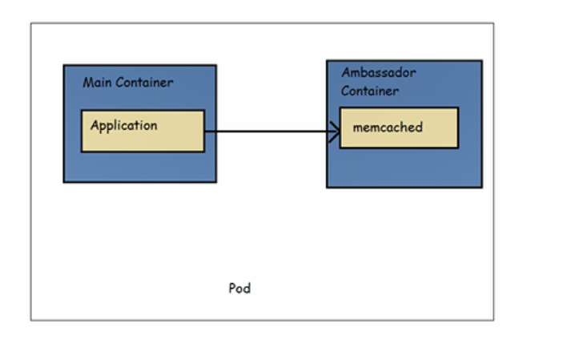

* Refer below for the sample created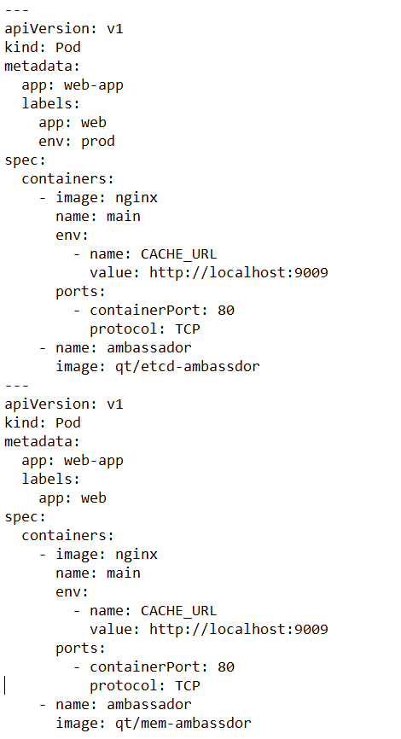

**Configuration Patterns**

* Every application needs to be configured and easy way to do it by storing configurations in code. This approach has side effect of configuration and code living and dying together.
* We still need the flexibility to adapt configuration without recreating application image.

**EnvVar Conifiguration**

* Config Map(https://kubernetes.io/docs/concepts/configuration/configmap/)
* Use environmental variables is easier way to setup configuration for simple use cases
* Environmental variables are set only before the application starts and we cannot change them later
* Refer Below for the manifest

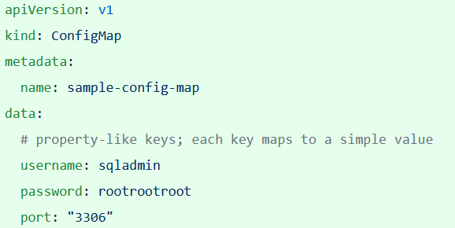

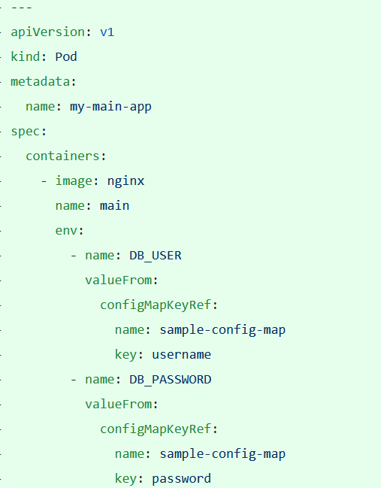

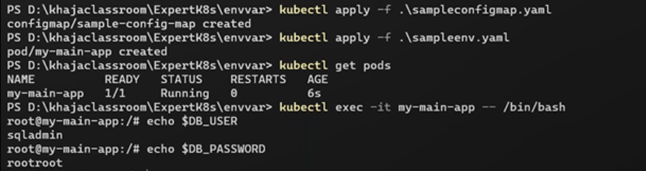

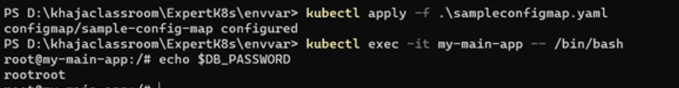

In Above approach variable would be configured during creation of pod, and once pod is created we can’t change variable value.

**Configuration Resource**

* One significant disadvantage of the EnvVar Configuration pattern is that it’s suitable for only a handful of variables and simple configurations.
* Often, it’s better to keep all the configuration data in a single place.
* Kubernetes has dedicated Configuration Resources that are more flexible than pure environment variables
* These are ConfigMap and Secret Objects for general-purpose configuration and sensitive data respectively
* Once a config Map is creating and holding data, we can use the keys of Config Maps in two ways
  + As a reference for environmental variables. Key is environmental variable
  + As files that are maaped to a volume mounted in a Pod. Key is file name
* The file mounted ConfigMap Volume is updated when the ConfigMap is update via k8s api.
* Refer below for the ConfigMap as volume mount.

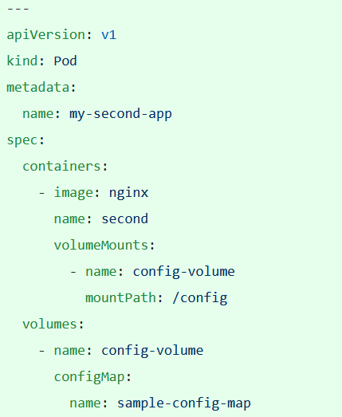

Initial file:

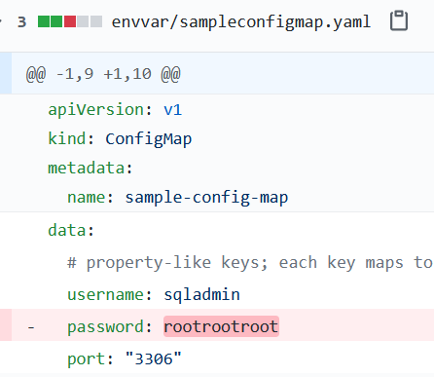

Later changes:

